Day 31 – GenAI Fundamentals

What is Generative AI?
Generative AI (GenAI) refers to a category of artificial intelligence systems designed to create new content. This content could be text, images, music, videos, or even 3D models. The key feature of GenAI is its ability to generate something new, often perceived as novel or creative, rather than producing outputs that are explicitly programmed.
Traditional AI usually focuses on:
- classification
- prediction
- recommendation
- detection

Examples of GenAI:
- Text Generation: Transformer-based models like GPT-4, which are capable of generating coherent and contextually appropriate text.
- Image Generation: Models like DALL-E that can create images from textual descriptions, e.g., drawing a picture of “a cat sitting on a couch and watching TV.”
- Music Composition: AI models like OpenAI’s MuseNet or Google’s Magenta, which can compose music in the style of famous composers.
- Video Generation: Platforms like Synthesia and Runway’s Gen-2 that generate video content, including virtual avatars or creative video scenes, by converting text scripts into videos.
- 3D Model Creation: AI models such as NVIDIA’s GauGAN or Autodesk’s generative design tools that can generate 3D models from text descriptions or based on design patterns.
- Voice Synthesis: Models like Tacotron 2, WaveNet, and newer technologies like VALL-E from Microsoft, which can generate realistic speech and mimic the voices of specific individuals.

What is a Large Language Model?
Large Language Models (LLMs) are actually a subset of GenAI, specifically designed to process and generate human language. These models are trained on huge amounts of text data and can understand, generate, and translate language. LLMs are a subset of GenAI but are specifically optimised for language-related tasks, such as conversation, translation, and summarisation.

Key Components of LLMs

A. Tokens
LLMs process text as tokens, not sentences.

B. Parameters
Parameters are learned weights inside the model.
More parameters generally mean:
- better capability
- better language understanding
- more compute cost

C. Context Window
The amount of text the model can remember during one conversation/request.
Small context:
- loses earlier information
Large context:
- better long-document handling

D. Training
LLMs learn patterns from huge text datasets.
They do NOT “memorize intelligence.”
They learn:
- language patterns
- structure
- associations
- statistical relationships
Examples of LLMs:
- GPT-4: Used for generating human-like text and engaging in conversations.
- BERT: Optimised for understanding the context of words in search queries.
- T5: A text-to-text framework that handles tasks such as translation, summarisation, and question-answering.
- RoBERTa: An optimised version of BERT with improved performance on a wide range of NLP tasks.
The key difference between GenAI and LLMs are:
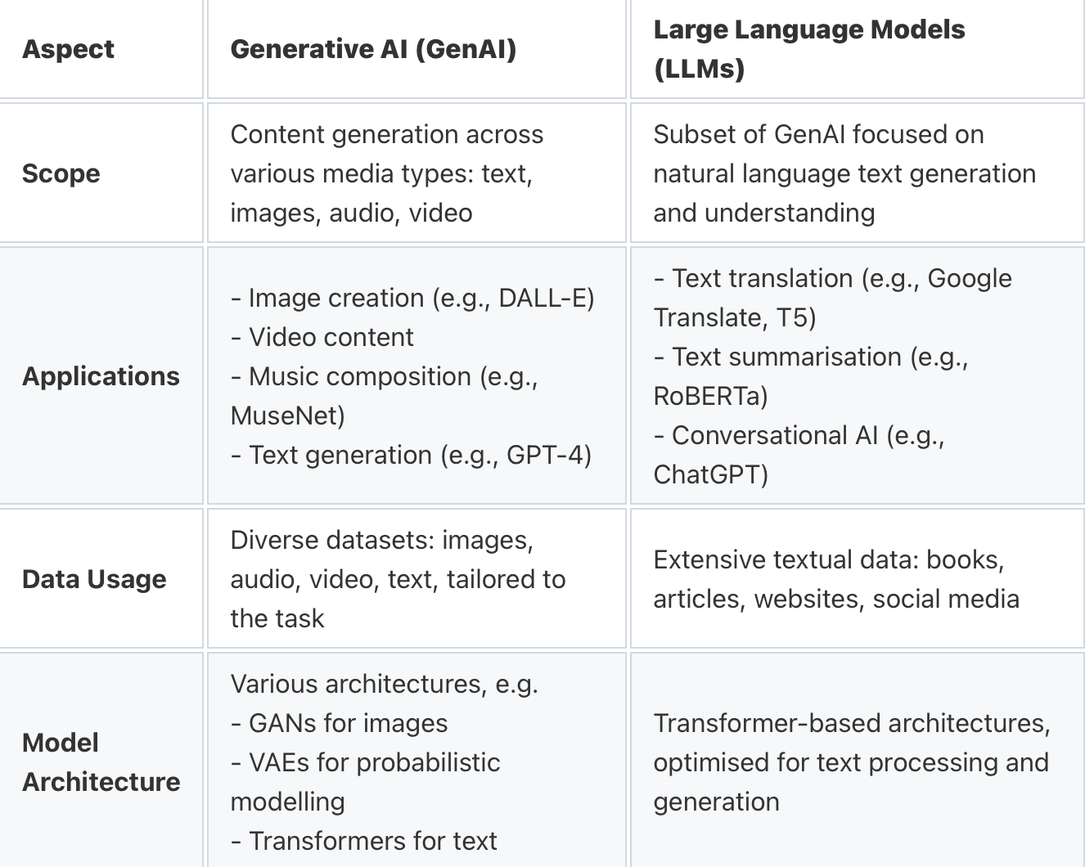
Traditional Data Science Workflow :
The traditional data science pipeline typically includes:
- Data Acquisition and Pre processing
- 2. Exploratory Data Analysis (EDA)
- 3. Model Development and Optimization
- 4. Model Interpretation and Reporting
- 5. Automation and Deployment
Each of these steps requires distinct skills — from statistical knowledge and coding proficiency to storytelling and decision-making. LLMs are now enhancing all these aspects simultaneously.
Integrating LLMs into Data Science Workflows :
Data Acquisition and Pre processing Pre processing is often the most time-consuming step, involving cleaning, formatting, handling missing values, and encoding categorical variables. With LLMs, these processes can be significantly accelerated through natural language automation.
Example Prompt:
“Write a Python function to clean a dataset by removing missing values, converting date columns, and standardizing categorical variables.”
Generated Code:
import pandas as pd
def preprocess_data(df):
df = df.dropna()
df[‘date’] = pd.to_datetime(df[‘date’])
df = df.apply(lambda x: x.str.lower() if x.dtype == ‘object’ else x) return df
This code, generated instantly by an LLM, replaces multiple manual steps and enables analysts to focus on insights rather than repetitive syntax.
LLMs can also help generate data documentation, summarizing datasets automatically, describing columns, identifying anomalies, and generating metadata files — reducing human error and ensuring consistent reporting standards.
3.2 Exploratory Data Analysis (EDA) :
EDA is the stage where patterns, relationships, and anomalies are discovered. Traditionally, it involves writing detailed scripts using Python libraries such as Pandas, Matplotlib, and Seaborn.
LLMs simplify this by converting plain English commands into visualization or statistical analysis code.
Example Prompt: > “Plot a correlation heatmap for all numerical variables in the dataset.”
Generated Code:
import seaborn as sns
import matplotlib.pyplot as plt
plt.figure(figsize=(10,6))
sns.heatmap(df.corr(), annot=True, cmap=’coolwarm’)
plt.title(“Correlation Heatmap of Numerical Features”)
plt.show()
Beyond generating visuals, LLMs can interpret the findings too. For example, they can explain why certain variables are correlated, suggest which features may be redundant, or highlight potential outliers.
By providing both code and context, LLMs help learners grasp deeper insights — combining the logic of programming with the narrative of analysis.
3.3 Model Development and Optimization :
This is the heart of any data science project. It involves selecting algorithms, building models, fine-tuning hyperparameters, and evaluating results.
LLMs, acting as intelligent co pilots, can assist by:
Generating boilerplate machine learning code.
Recommending suitable algorithms for a given dataset.
Suggesting performance metrics and evaluation methods.
Example Prompt: > “Build a logistic regression model to predict customer churn using Scikit-learn.”
Simplified LLM Output (conceptual): The model provides a complete workflow including data splitting, model fitting, and evaluation with accuracy, recall, and F1-score metrics.
● LLMs can even guide optimization strategies:
● Applying SMOTE for imbalanced datasets.
● Adjusting regularization parameters to reduce overfitting.
● Using cross-validation for model robustness. This drastically shortens experimentation time while ensuring conceptual clarity.
3.4 Model Interpretation and Reporting :
Once a model is built, interpreting its results and communicating them clearly is crucial. LLMs can generate comprehensive reports summarizing performance metrics and explaining the behaviour of complex models like Random Forests or Neural Networks.
Example Prompt: > “Summarize my model’s performance and recommend improvements.”
Sample Output: > “Your Random Forest model achieved an accuracy of 91%, indicating strong predictive capability. However, the difference between training and validation accuracy suggests slight overfitting. You may consider reducing the number of estimators or using dropout regularization. Feature importance analysis shows that customer tenure and service usage are the strongest predictors of churn.”
Such reports are clear, concise, and business-friendly — enabling better communication between technical teams and stakeholders. LLMs also assist in data storytelling, automatically converting statistical results into coherent narratives that non-technical audiences can understand.
3.5 Automation and Integration:
Beyond individual tasks, LLMs are now being embedded into automated workflows using frameworks like Lang Chain and Llama Index. These integrations enable the creation of end-to-end pipelines that:
● Query databases using plain English.
● Run data transformations autonomously.
● Generate reports or dashboards instantly.
For example, enterprise tools like Power BI Co pilot and Tableau GPT use LLMs to let users ask,
> “Show me sales performance by region for Q2,” and instantly receive a generated visualization.
This democratizes data analysis — empowering even non-programmers to interact with data intelligently.
As organizations adopt these systems, data science becomes less about coding complexity and more about strategic insight generation.

Limitations of LLMs in Data Science

A. Hallucinations
LLMs can fabricate:
- statistics
- research papers
- citations
- code
Never trust blindly.

B. Lack of True Reasoning
They simulate reasoning patterns.
That is not the same as actual reasoning.

C. Outdated Knowledge
Some models may not know:
- latest APIs
- latest events
- new libraries

D. Privacy Risks
Uploading sensitive data into public AI systems can be reckless.
Never upload:
- customer PII
- confidential datasets
- API keys
- medical records
without proper controls.

